Post Details |  | Last Updated: 01/10/2025
Faculty/Administrative/Service Department | Events Team
Job Title | Events Coordinator (Fixed-Term Contract)
Job Family | Professional Services |  | Job Level |  | 3
Responsible to | Events Officer
Responsible for (Staff) | N/A
Job Purpose Statement

The Events Coordinator will work with the Events Officer to successfully organise, implement, promote and evaluate a programme of events to promote student recruitment activities including Open Days and Offer-Holder Days. In addition, they will support University-wide events such as Graduation and other large-scale events that are aligned with key strategic objectives. The role will involve working with a wide range of stakeholders.
Key Responsibilities
- Work closely with the Events Officer to plan, manage, promote and evaluate a range of events to promote student recruitment activities.
- Support the Events Officers and Head of Events in the successful delivery of large-scale events such as Graduation.
- Coordinate the operational delivery of small to medium-sized events, ensuring that all logistics are arranged in good time and to a high standard.
- Coordinate the recruitment, training and management of Student Ambassadors and Helpers required, as well as organising pay through UniTemps.
- Manage the enquiries Mailbox, responding to queries in a timely fashion.
- Take on the guardianship of all events-related resources including tablecloths and A-frames and ensure that they are adequately maintained and their loan to the wider University community is efficiently administrated.
- Provide additional support to the Events Officers and Head of Events as and when required.
N.B. The above list is not exhaustive.

All staff are expected to:
- Positively support equality of opportunity and equity of treatment to colleagues and students in accordance with the University of Surrey Equal Opportunities Policy.
- Work to achieve the aims of our Environmental Policy and promote awareness to colleagues and students.
- Follow University/departmental policies and working practices in ensuring that no breaches of information security result from their actions.
- Ensure they are aware of and abide by all relevant University Regulations and Policies relevant to the role.
- Undertake such other duties within the scope of the post as may be requested by your Manager.
- Work supportively with colleagues, operating in a collegiate manner at all times.

Help maintain a safe working environment by:
- Attending training in Health and Safety requirements as necessary, both on appointment and as changes in duties and techniques demand.
- Following local codes of safe working practices and the University of Surrey Health and Safety Policy.
Elements of the Role

Planning and Organising

- The post holder will work to ensure the successful planning, promotion, implementation and evaluation of a series of events from conception to completion.
- The post holder will work on a range of projects concurrently and must therefore operate flexibly and react positively to changing circumstances and requirements.
- The post holder will need to demonstrate good communication and customer service skills to develop positive working relationships with individuals and departments within the University.
Problem Solving and Decision Making

- With a varied events calendar, the post holder will work on a range of projects concurrently, requiring flexibility and a positive reaction to changing circumstances and requirements. The post holder therefore, has the latitude within their daily/weekly work routine to organise and prioritise their work to ensure key deadlines and objectives are met.
- The post holder is expected to provide advice and solutions to routine day-to-day problems within the specialist area in which they are familiar; event planning, catering etc. Resolution for these issues will usually be found through referring to their previous experience of similar problems or through making reference to University policies and procedures. They are expected to take a pro-active approach to identifying ways to address these issues and to implement them under the guidance of their line manager.
- The post holder will work within established processes and procedures with minimum day-to-day supervision in the organisation and delivery of their work. There is scope for the post holder to apply judgement and initiative when managing their workload, including any medium-term priorities and when responding to any conflicting demands. They will also have the freedom to work in a proactive manner and to decide how to achieve the end result, generally based on their own judgment and experience. The post holder will, however, receive guidance and regular support from their line manager.
Continuous Improvement

- The post holder will be expected to continually seek to improve the events they run and the event planning processes to improve operational efficiency and service quality. The post holder will be active in seeking internal and external feedback for events, ensuring success is clearly defined at the outset of each project in order for it to be measured.
- With budgets in mind, they will also be expected to consider ways of ensuring value for money without compromising on quality – factoring in the possibility of income generation with every event opportunity.
Accountability

- The Events Coordinator will work within established University processes and procedures to ensure that high standards are maintained. They will also be familiar with the University’s brand guidelines and ensure that they are adhered to in an events context.
- There is scope within this role for the post holder to apply judgement and initiative when managing their workload, although they will be expected to defer to the line manager if they are unsure of the best course of action.
- They will be expected to report on their progress in regular one to ones with their line manager at which point there will be an opportunity to ask questions and discuss challenges.
- They will be expected to represent the Events Team at key meetings.
Dimensions of the role

- The Events Coordinator does not have any direct reports, but they will be expected to work well with others and provide direction if leading on the organisation of an event.
- The post holder will be responsible for helping to manage and monitor designated budgets for the key projects that they are assigned.
Supplementary Information

- The Events Coordinator will be expected to attend events outside of normal working hours as a core part of their remit. They will be expected to attend all University Open Days, Graduation and other large-scale events unless there are exceptional circumstances preventing them from doing so.
Person Specification
Qualifications and Professional Memberships |  |  |  |  |  | Essential/  Desirable
HNC, A Level, NVQ 3, HND level or equivalent with a minimum of three years relevant experience  OR  Broad vocational experience (minimum five years), acquired through a combination of job-related vocational training and considerable on-the-job experience, demonstrating development through involvement in a series of progressively more demanding relevant work/roles. |  |  |  |  |  | E  D
Technical Competencies (Experience and Knowledge) |  |  |  | Essential/  Desirable |  | Level  1-3
Experience in successful events management from concept to completion |  |  |  | E |  | 2
Operational knowledge of approaches central to the running of events such as organising staging, catering, AV equipment, designing and managing display equipment, signage, invitations and programmes |  |  |  | E |  | 2
Experience of using a customer management database |  |  |  | E |  | 2
Experience of the Higher Education Sector |  |  |  | D |  | n/a
Special Requirements: |  |  |  | Essential/  Desirable |  | Level  1-3
Flexibility to work outside of core office hours (including evening, weekends and bank holidays) |  |  |  | E |  | n/a
The post holder has a key role in the preparation and the delivery of University Open Days, Applicant Days and Graduation ceremonies and annual leave should not normally be taken during this period |  |  |  | E |  | n/a
Core Competencies |  |  |  |  |  |  | Level  1-3
Communication  Adaptability / Flexibility  Customer/Client service and support  Planning and Organising  Teamwork  Continuous Improvement  Problem Solving and Decision-Making Skills  Leadership / Management  Creative and Analytical Thinking  Influencing, Persuasion and Negotiation Skills  Strategic Thinking |  |  |  |  |  |  | 2  2  2  2  2  2  2  n/a  1  2  n/a
Organisational/Departmental Information & Key Relationships
This post is based within the Global directorate at the University of Surrey.
The directorate engages with a wide range of people and organisations in order to grow influence and reputation and advance the global ambitions of the University.
The Directorate is comprised of five distinct departments: Advancement, incorporating Advancement Services and Philanthropy, International Engagement, International Recruitment and Marketing & Communications incorporating the Events Team and Public Affairs. This particular post is based within the Events Team.
The Events Team are a team of seven events management professionals dedicated to delivering a diverse portfolio of high quality events including Royal and State Visits, VIP receptions, ministerial engagements, building openings, annual lectures, graduation ceremonies, open days and many more.
The role requires regular liaison with the entire Global Directorate and for the post holder to be a strong team player, as well as able to work under their own initiative. Specifically, the Events Coordinator is managed by the Events Officer and works closely with them to develop the strategy for the events programme.

Department Structure Chart

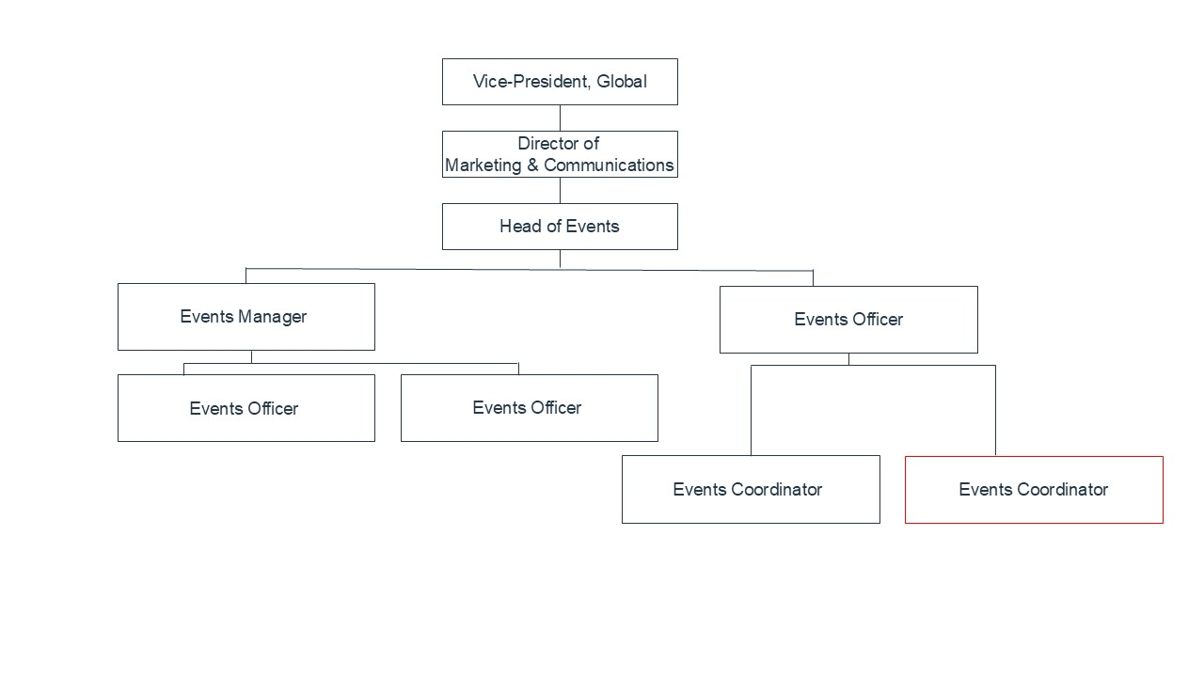

Relationships
Internal
- All colleagues within the Global Directorate
- Student Marketing, Recruitment, Outreach and Admissions
- Vice-Chancellor’s Office
- Colleagues in the three Faculties
- Hospitality & Catering
- Estates & Facilities

External
- University of Surrey alumni, retired staff, honorary graduates, donors and potential donors
- External philanthropic partners (e.g. trusts, foundations and corporate partners)
- Other local event venues e.g. hotels and conference spaces
- Local Borough Council
- Local tourism and trade leads e.g. Visit Surrey and Experience Guildford

